**A+ Computer Science IFS – Jeroo Project Lab Value - 100**

**Lab Goal:** This lab was designed to help you review loops, methods, if statements and to learn more about how you can combine them. You must determine how and when to turn, when to pick flowers, and most importantly when to stop. You must create if commands based on the requirements of this problem. Pay close attention – it will only require a few basic decisions if you take a careful look at the decisions that need to be made.

**Lab Description:** This lab requires that you use methods with looping of if statements. Your Jeroo must make its way and reach the center, stop before jumping into the water, and pick all the flowers.

**Starting Screen:**

**Files Needed:**

**JerooProject.jsc**

**JerooProject.jev**

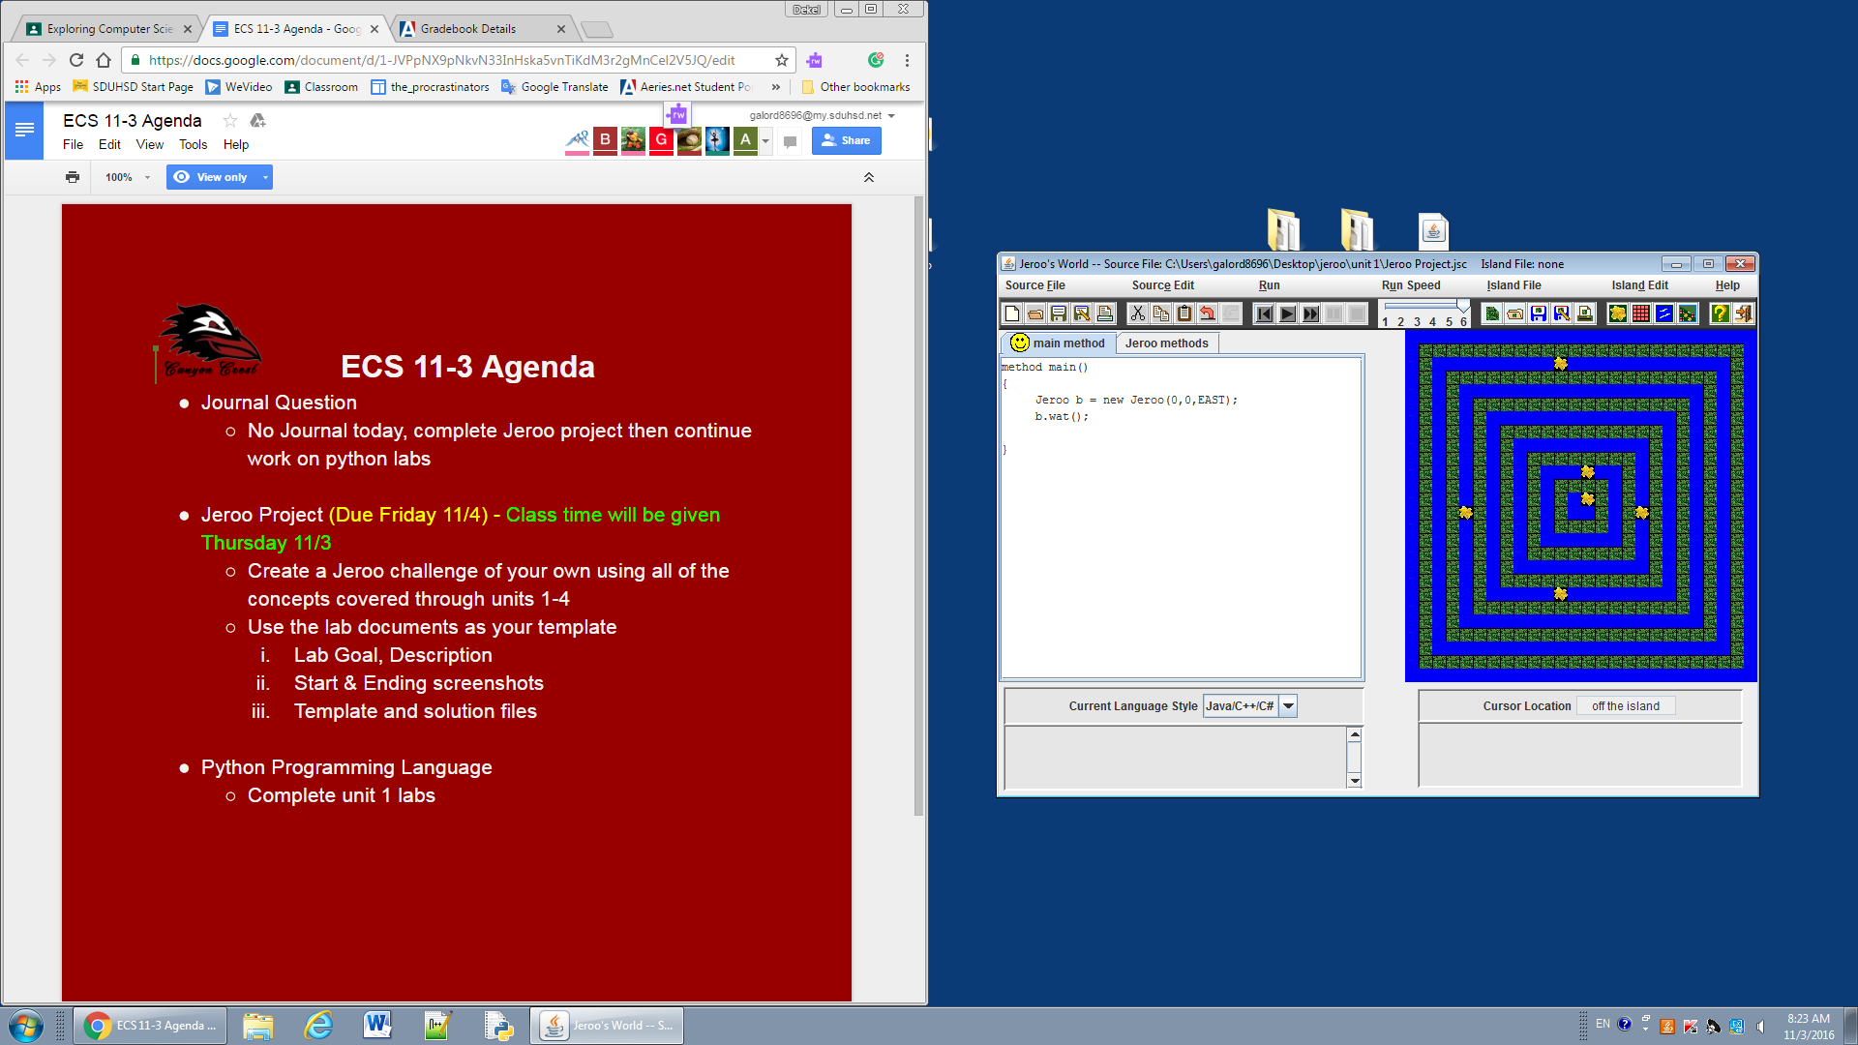

***algorithm help***

**Preconditions**

* **I am facing the path?**
* **Is it clear to move ahead?**
* **Do I turn now?**
* **Should I stop?**

**Postcondition**

* **Successful hop through the water to the center**
* **Jeroo is not in the water**
* **Jeroo is facing south**

**Solve it using recursion for extra credit!!!!!**

**Ending Screen:**

